Risk Rating Matrix for SCRC

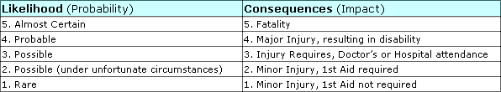

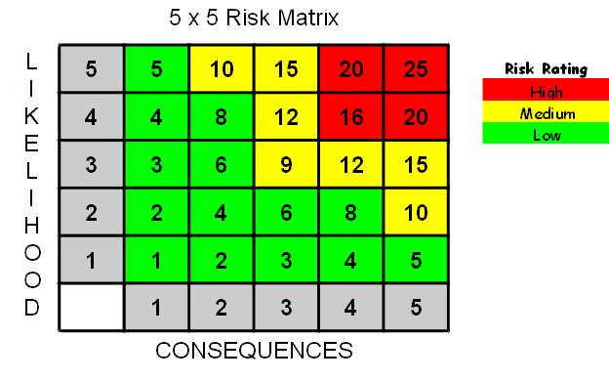

Risk Rating is calculated by multiplying the likelihood against the consequences, e.g. taking a likelihood of 4, which is classified as Probable, and multiplying this against a consequence of 2, which is classified as a Minor Injury 1st aid required, would give you and overall risk rating of 8, which would be risk rated as a low risk.

High risk equals 16 to 25.
High Risks activities should cease immediately until further control measures to mitigate the risk are introduced.

Medium risk equals 9 to 15.
Medium Risks should only be tolerated for the short-term and then only whilst further control measures to mitigate the risk are being planned and introduced, within a defined time period. Note: Medium risks can be an organisations greatest risk, it's Achilles heel, this due to the fact that they can be tolerated in the short-term.

Low risk equals 1 to 8.

Low Risks are largely acceptable, subject to reviews periodically, or after significant change etc...

